California State University Fullerton

CPSC 462



Object Oriented Software Design

Use Case Model

for the



Hotel Room Reservation

System

|  |  |  |
| --- | --- | --- |
|  | **Allen Rivas** |  |
|  | Chief Technical Officer (CTO) |  |
|  | [allen.rrivas30@csu.fullerton.edu](mailto:allen.rrivas30@csu.fullerton.edu) |  |

Revision History:

| Version | Date | Summary of Changes | Author |
| --- | --- | --- | --- |
| 1.0 | March 23, 2021 | * First draft. To be refined primarily during the elaboration phase. | Allen Rivas |
| 1.1 | May 11, 2021 | * Updated draft with new logo. Updated the Use Case Diagram and Use Case Brief Descriptions. | Allen Rivas |
| 1.2 | May 16, 2021 | * Updated this draft by adding change bars to indicate the changes that have been made. | Allen Rivas |

Table of Contents

1 Use Case Diagram 1

2 Use Case Brief Descriptions 2

2.1 Reservation 2

2.2 Check-in 2

2.3 Generate Report 2

# Use Case Diagram

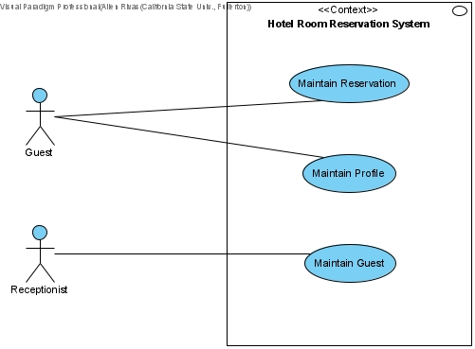

# Use Case Brief Descriptions

## Reservation

The guest requests a list of rooms of available rooms providing the specifications of number of guests, arrival, and departure date. The system responds with a list of available rooms given the specifications (hotel, room type, cost per night, and total price). The guest requests a list of services providing the specific hotel. The system responds with a list of services with cost. The guest requests to make a reservation with a room providing hotel, type of room, number of guests, arrival and departure date, and amenities. The system responds with desired reservation. The guest makes a request to pay for the reservation and provides guest name, credit/debit information (card number, expiration date, and CV). The system responds with a confirmed reservation number.

Alternatives include cancel reservation, change the arrival and departure dates.

## Check-in

The guest requests all personal information on current profile. The system responds with name, address, personal phone number, and email. The guest requests to membership status on current profile. The system responds with list of membership points. The guest requests payment information on current profile. The system responds with list of credit/debit information (number and expiration date).

Alternatives include create, read, delete, and update profile.

## Generate Report

The receptionist request to list the guest’s reservation providing the guest’s name and confirmation number. The system responds with the guest’s reservation information (room type, floor preference, and room number). The receptionist request room assignment providing guest’s name, credit/debit information and room number. The system responds with room number and receipt of payment. The receptionist requests a room key given the guest’s name and room number. The system responds with the specified room key for the given guest.

Alternatives include check in/out guest, and additional payments for the different room amenities.